# SYSTEM TESTING

It is an end to end testing where in the test environment is just similar to the production environment.

**End-end testing:**

Navigate through all the features and check whether the end feature is working as expected or not.

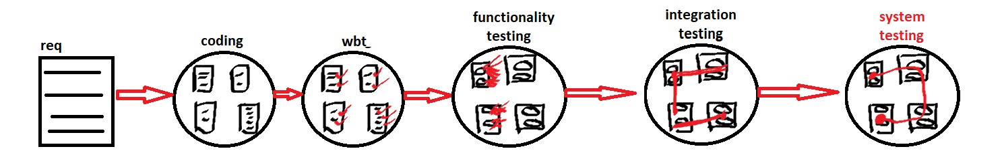

**Types of environment:**

*Development environment****:***

It is a setup which is used for developing the software. It consists of hardware, software, server, network.

*Test environment:*

It is a setup which is used for testing the software. It consists of hardware, software, server, network.

*Production environment:*

It is a setup which is used for run the software for business which contains hardware, software, server, network.

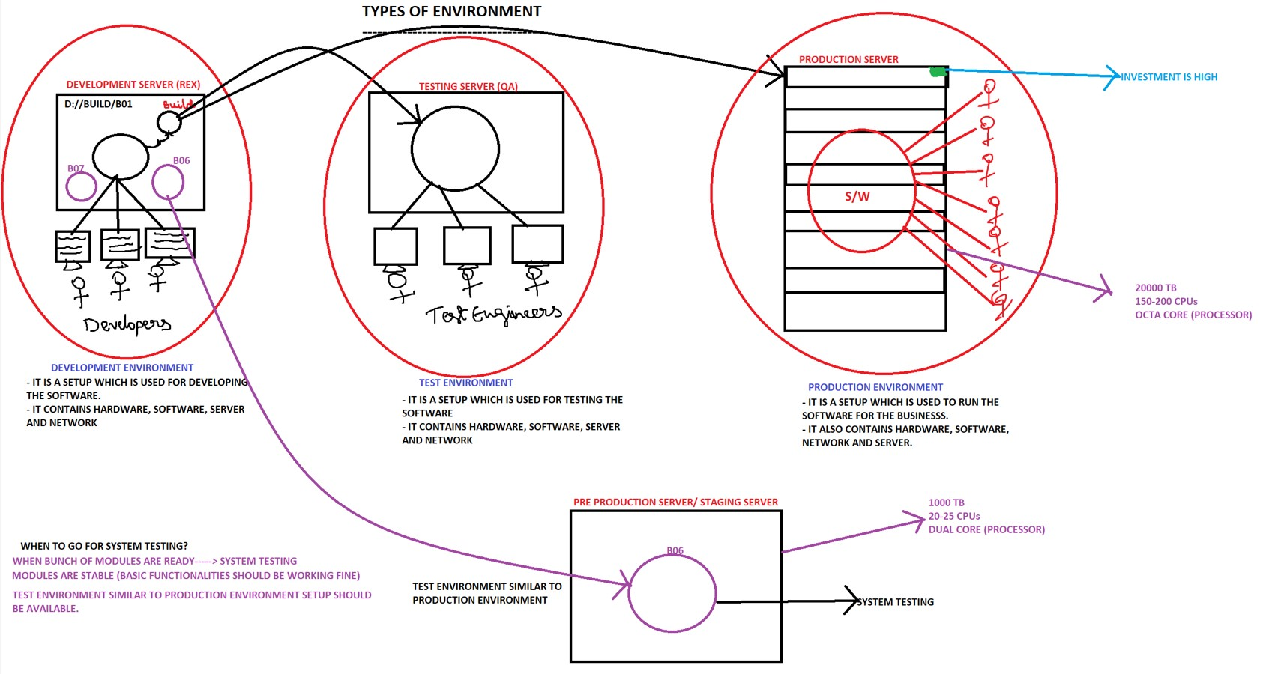

**When new build comes:**

* Test new module (probability of catching bugs is very high)
* Test integration between old and new module
* Retest fixed bugs
* Test the old modules

**Why we find new bug in the old module?**

* Chances are there adding new features would have introduced a bug in old module
* Fixing one bug would have introduced another bug
* Chances are there we would have missed it in previous cycle and found in current cycle

**When we do System Testing?**

* If the environment similar to the production environment is available
* When modules are stable (basic functionalities should be working fine)
* When minimum bunch of modules are ready

**Release process:**

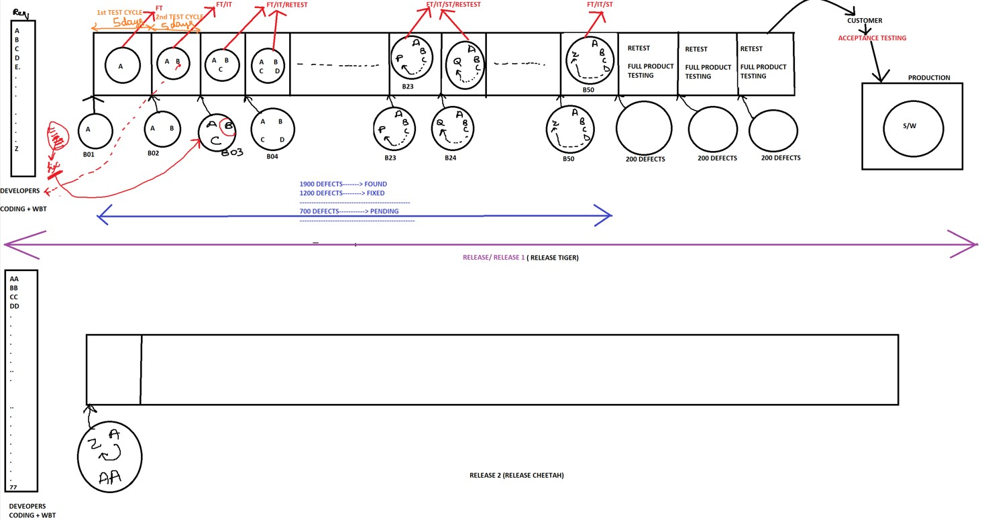

**What is Release?**

Starting from collecting/gathering the requirement, developing the software and testing the software for many cycles and installing/ deploying the software to the customer is called as Release/ 1-Release.

Generally, 1- release might take 6 months – 1 ½ years. If it is Agile it might take 1 month.

**When do you release the product to the production?**

* When there is no blocker/ critical bug
* When all the end to end business scenarios are working fine
* When all the features requested by customer are ready
* If the product is tested in environment similar to production environment

**What is Test Cycle?**

It is the effort/ time/ duration spent by the test engineer to start and finish complete product testing is called as 1 test cycle **(or)** time taken to test one complete build. Each test cycle might take 3, 5 or 15 days. It just depends on:

1. No. of engineers
2. Complexity of the software
3. Size of the product

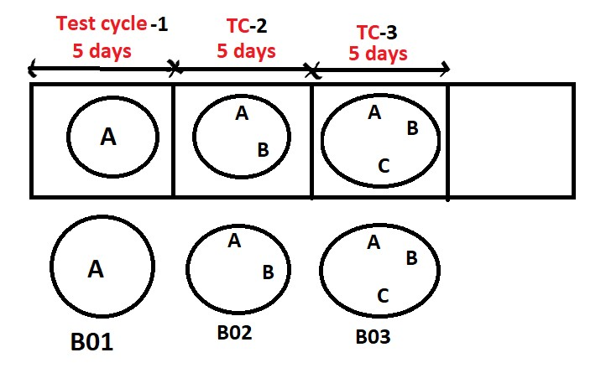

**What is Respin?**

- The process of getting a new build within one test cycle is called as Respin. - If there are blocker defects, we will get respin.

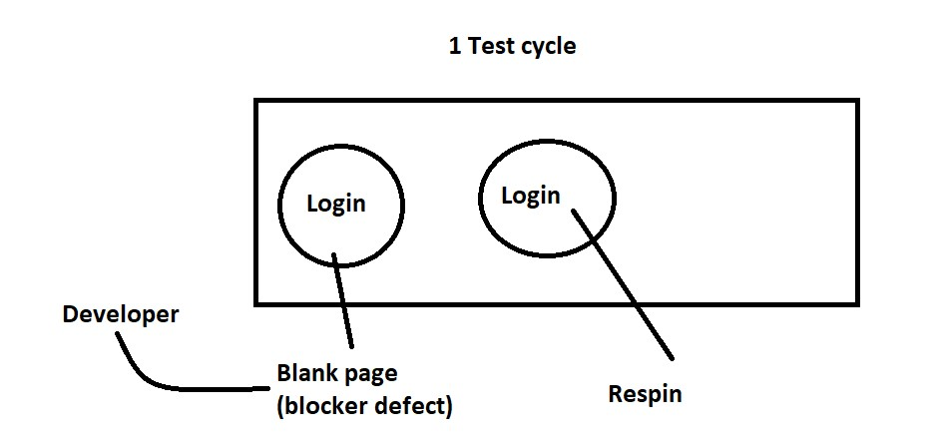

**What is Build?**

All the programs are compiled then we get binaries and all the binaries are archive/ compressed and that is called as build.

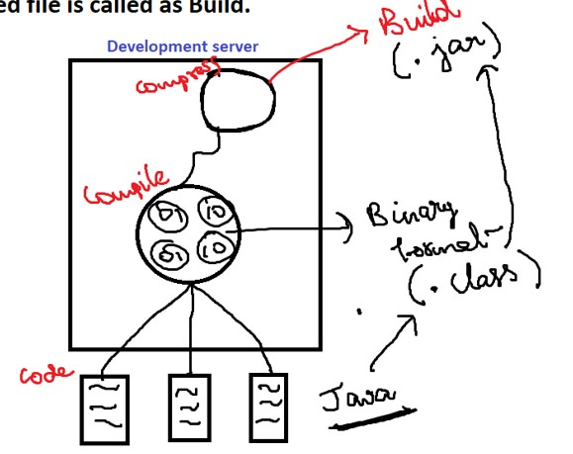

**What is Patch?**

Patch is a small software which contains modified programs, new programs and record of deleted programs.

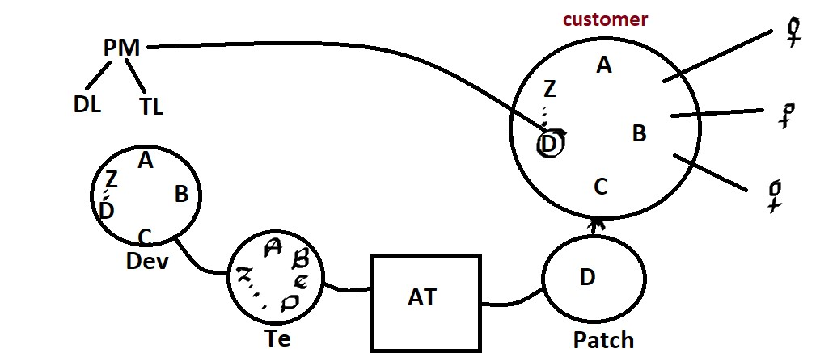

**Who will be involved in the installation of software?**

1. Anybody from the Testing team
2. Anybody from the Development team
3. Build engineer/ Release engineer

*How the build mails come from development team: -*

Hi Team,

New build B01 is ready

The test URL: https://qa.citibank.com

UN: abcd

PWD: xyz

Happy testing!!!!

**Role of Release Engineer**

* Maintain the source code
* Create a build
* Install build in test environment
* Release the product to the production

***Continuous Integration (CI):*** Continuous synchronization between developmentserver and testing server.

***DevOps Engineer:***Manages the code, compile, compress, install and release to the production. This activity is an operation. So, it is called development operations.

